Solution Of Astronomy Question :

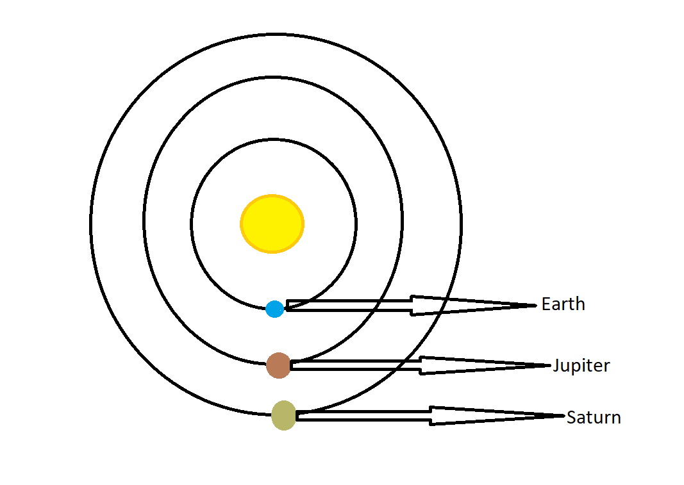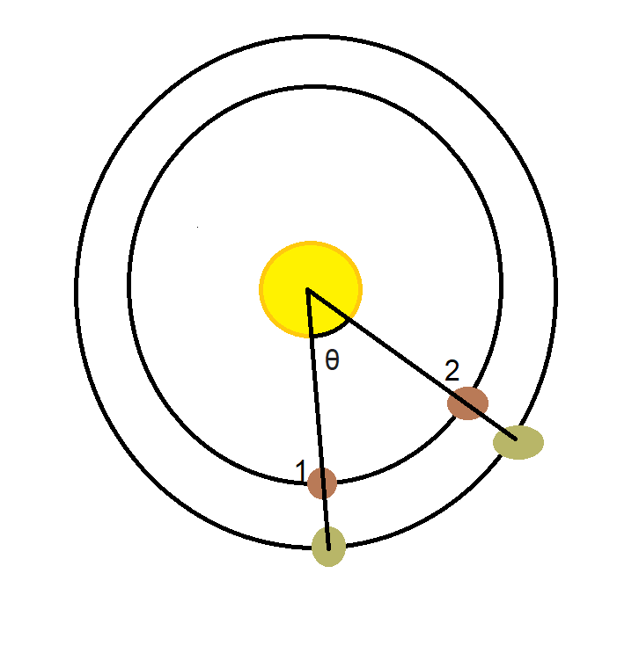

Let the time after which Jupiter and Saturn will align with earth be “S”(Synodic Period) earth days.

S is going to be greater than J because Jupiter orbits faster than Saturn around sun. So atleast one revolution should be there after their earlier conjunction.

After time J ( Orbital Period Of Jupiter around sun in earth days) the Jupiter will come at position 1 again. ( 1= earlier position of conjunction or starting point we considered for problem).

Let the orbital time period of Saturn around sun be “X”.

Now after (S-J) days jupiter will align with saturn.

Now, In J time Jupiter covers= 360 degree of revolving.

So in 1 time unit Jupiter covers = 360/J degree of revolving.

Then in (S-J) time Jupiter cover = 360/J *(S-J)=(θ)degree of revolving.

Similarly, In time X Saturn covers = 360 degree of revolving.

So, in 1 time unit Saturn covers = 360/X degree of revolving.

So in time S Saturn covers = 360/X * S = (θ)degree of revolving.

As both are (θ) from figure:

Equating: 360/J *(S-J) =360/X* S



S/J – 1= S/X

S/J -S/X = 1.

1/S = 1/J – 1/X.

As we know already J(approx.) in terms of earth days = 4,333.

And X ( approx.) in terms of earth days= 10,759.

We have to calculate the value of S i.e time after which all the planets will align at new position “2”. So putting the value of J and S in above equation we get:

S = 7253 earth days (approx.) 7253 earth days are around 7253/365 (ignoring leap years)= 19.871 years.

Now ,0.871*365=317.915 Now, 365-317.915= 47.085 Days.

So this is about more than 19 years and 10 months or little less than 20 earth years.

So this type of conjunction will occur after every 20 years around.

**So maximum conjunction that can occur within 365 consecutive days is 1.**

So next time this is going to happen in **November 2040**.

In December 2020 this was in constellation Capricornus. Constellation took their same position after 1 year at a place. But as this is in November not in December this can not happen in same constellation again. Next time this is going to happen in Constellation

**“VIRGO” .**